The COVID Roadmap Spring 2021

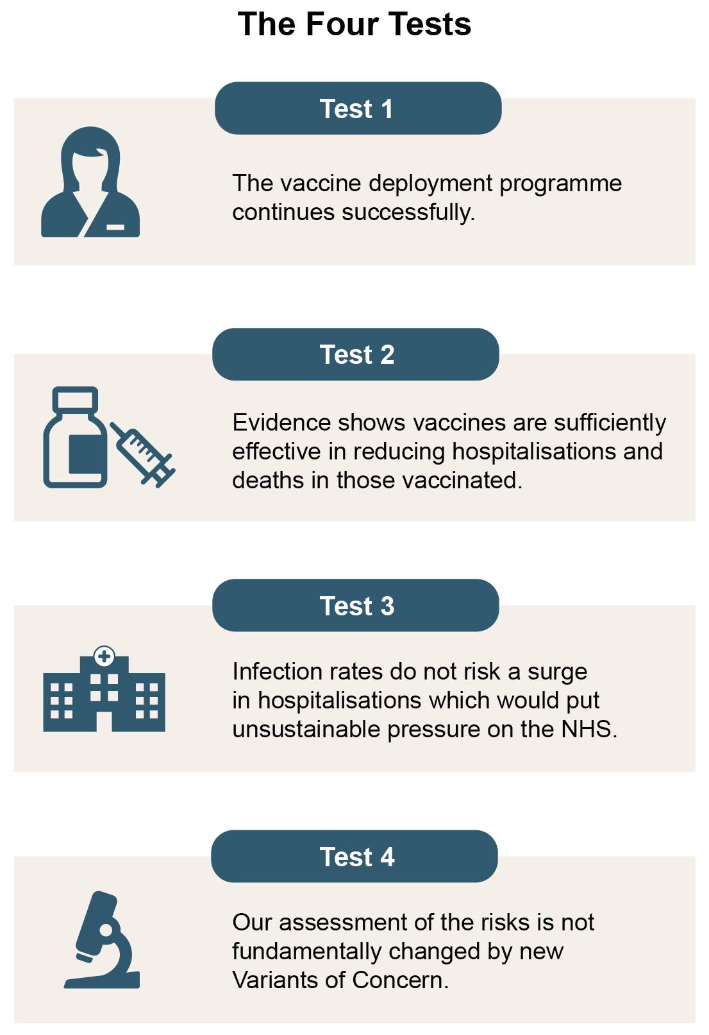

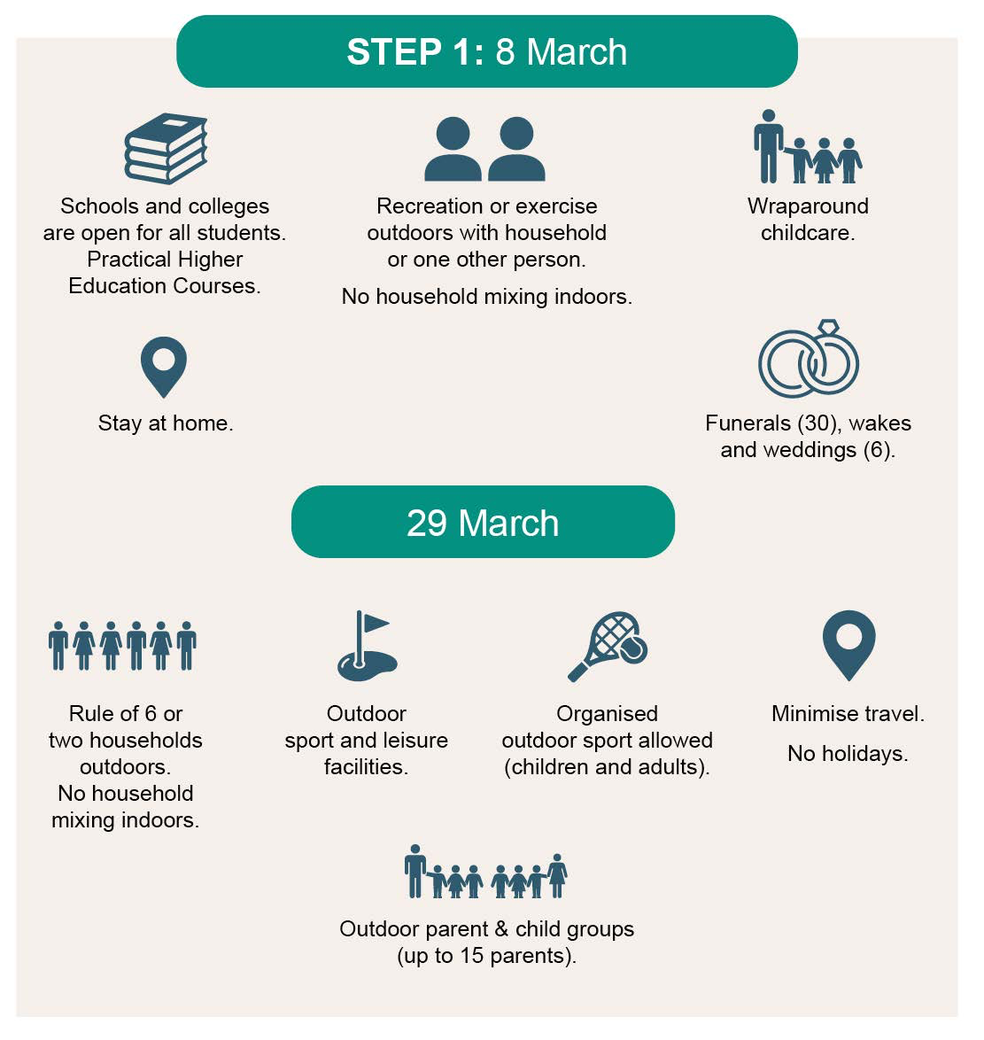

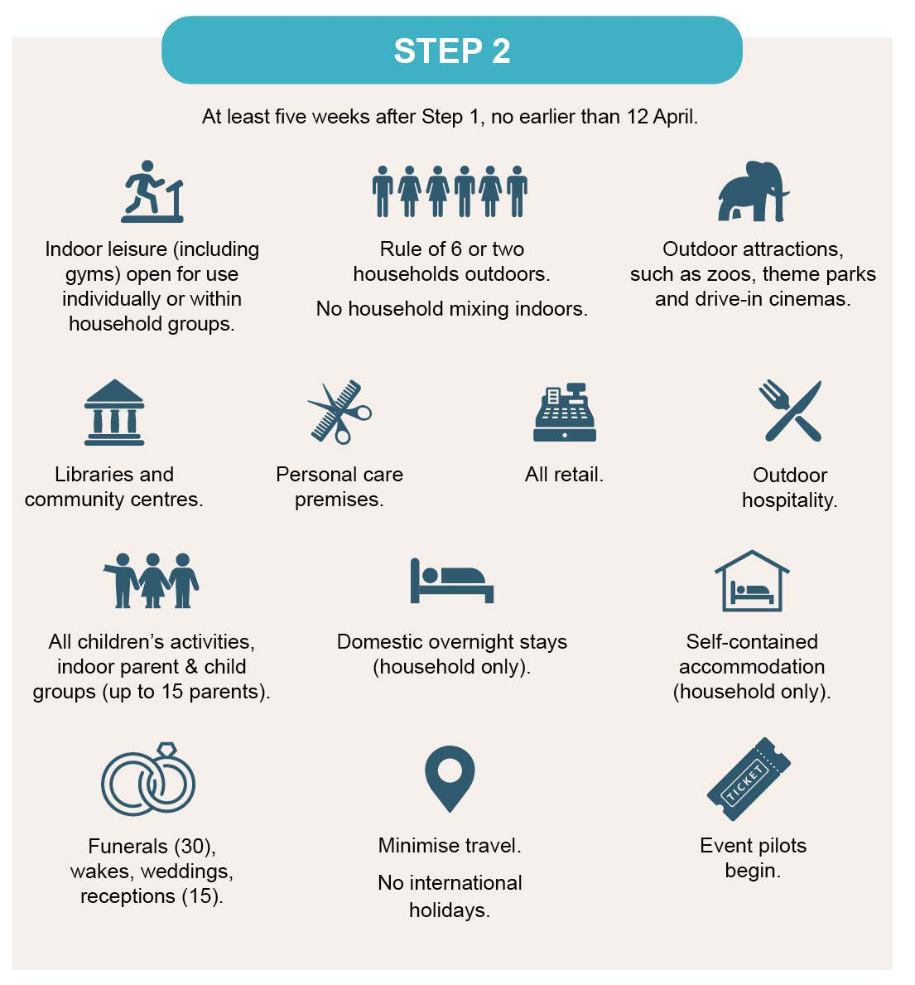

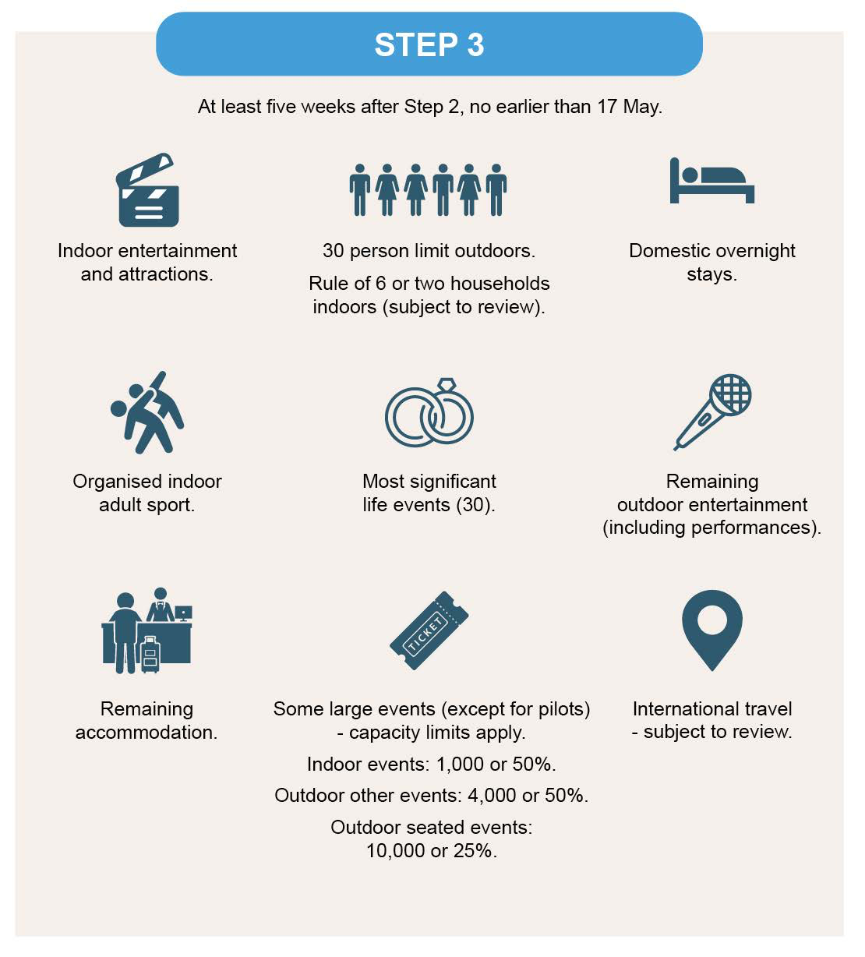

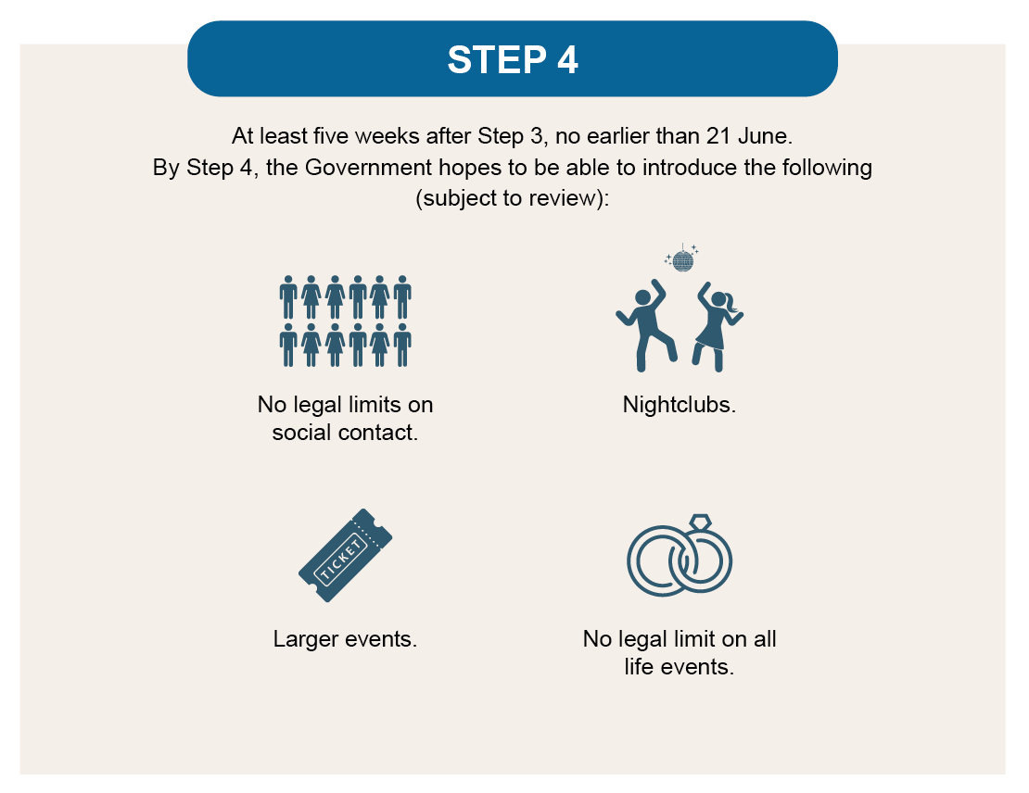

Brief commentary from CPT

It would seem that the interpretation of the proposed guidance (and this is my personal interpretation) is that the following apply to sacramental celebrations outside of the “extraordinary” circumstances that we currently have:

For Marriages:

Not earlier than 8 March 6 people (not including anyone who is working)
Not earlier than 12 April 15 people (not including anyone who is working)
Not earlier than 17 May 30 people (not including anyone who is working)
Not earlier than 21 June no restrictions on numbers

For Funerals:

Not earlier than 8 March 30 people (not including anyone who is working)
Not earlier than 12 April 30 people (not including anyone who is working)
Not earlier than 17 May 30 people (not including anyone who is working)
Not earlier than 21 June no restrictions on numbers

For Baptisms:

Not earlier than 17 May 30 people (not including anyone who is working)
Not earlier than 21 June no restrictions on numbers

Rev. Canon Christopher Thomas
24th February 2021

