
Knowledge Organiser- Science Year 4- Human Body
Key Vocabulary | Definition
digestion | The process by which food is converted into substances that can be absorbed into the body.
salivary glands | Any of three pairs of glands in the mouth and digestive system that secrete saliva for digestion
peristalsis | Movement of organ walls that propels food and liquid through the digestive system
oesophagus | The tube that leads from the mouth through the throat to the stomach.
stomach | The organ into which food passes from the oesophagus for mixing and digestion before passing to the small intestine
small intestine | The main site of the digestion of food into small molecules which are absorbed into the body.
large intestine | Takes water and some minerals from leftover food material and creates solid waste.
urethra | A tube that connects the bladder to the outside of the body
vitamins | Substances necessary for the healthy functioning of our bodies

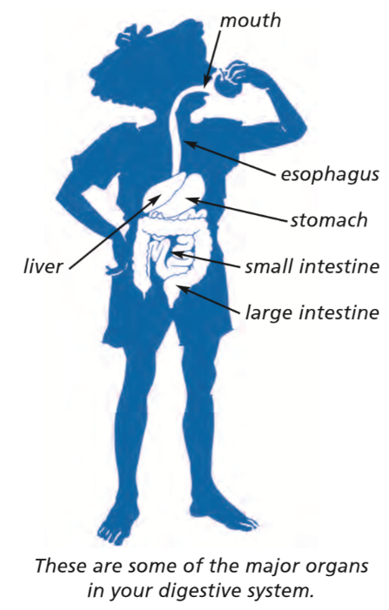

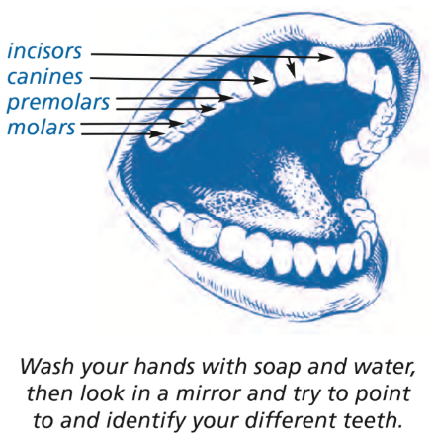
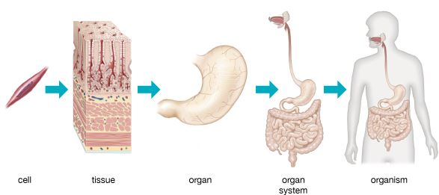
With a very powerful microscope, you can see what some cells look like:



