English  In English this term we will begin by preparing to write a formal persuasive letter based on a previous unit of work completed on London. The children will be taught to use the correct language and presentation features to help persuade someone to visit the city of London.  They will also study ’Lob’ by Linda Newbury, learning about the story of the mysterious Green Man and the changing seasons of the year. They will write in role as key characters and make use of figurative language in their own narrative texts based on the book. | Maths  The children will further develop their understanding and application of formal written methods for multiplication and division.  They will learn about decimal notation and link this to what they know about fractions. They will be taught about tenths and hundredths, equivalent fractions and how to simplify them.  They will revisit how to add and subtract fractions as well as how to find a fraction of a quantity.  The children will also carry out a short block of work on finding the area of a shape. |  | Science  During the first half term the children will complete a unit of work on Classification. They will learn about classification keys and use them to identify different species of plants and animals. The children will become familiar with the terms vertebrates and invertebrates. They will also be able to identify the key features of reptiles, amphibians, mammals, fish and birds as well as insects, arachnids and molluscs.  In the second half term we will be learning about states of matter and the water cycle. The children will develop their understanding of evaporation and condensation and precipitation.
History  The children will continue to look at Ancient Rome. However, this term we will look at the rise and fall of Rome. We will learn about the Punic Wars and the expanding Roman empire. We will then look at the Roman emperors Julius Caesar and Augustus. Finally, we will learn about Pax Romana, Christianity, and finally the fall of the Roman empire. |  | PSHE  In PSHE this half term we will be learning about how to look after and respect our bodies. We will consider how to stay safe in our bodies and reflect upon our emotional well-being. The children will also learn about how the media can influence how people feel about themselves. Finally, we will be learning about harmful substances which can have an impact on our bodies such as alcohol and tobacco.
Geography  In geography, we will be looking at a different part of Europe – Eastern Europe. We will be exploring physical features of Eastern Europe. We will compare both human and physical characteristics to those of the UK and Russia. We will be considering the differences in climate across Eastern Europe as well as in Russia. |  |  | Computing  In computing, children will be looking at how to use spreadsheets, collect data and interpret that data. They will collect data relating to the weather and input this using spreadsheets and Excel.
Physical Education  The children will complete a unit of work on Dance using the James Bond and Mission Impossible themes as the inspiration for their own routines. They will learn how to perform a ‘slide and roll’ and incorporate movements which reflect a superhero theme in the last few weeks.  After half term, we will move on to Athletics. The children will investigate ways of running, jumping and throwing using different equipment to measure, time and compare different styles. | Music  In Music we will be learning how to write short compositions. The children will use a musical stave to write line and space notes and they will use pitched instruments to play their pieces. They will continue to work on recognising the length of different musical notes such as crotchets, minims, quavers and semi breves. They will also take part in their weekly Trumpet lesson with Mrs Hadlington. |  | Art  In art Year 4 will learn about monuments of ancient Rome. They will look at the Pantheon, studying its space and symmetry and undertake an extended project to make their own models of it using lolly pop sticks and papier-mache. They will also learn about the construction of the Colosseum and the story told by Trajan’s Column.
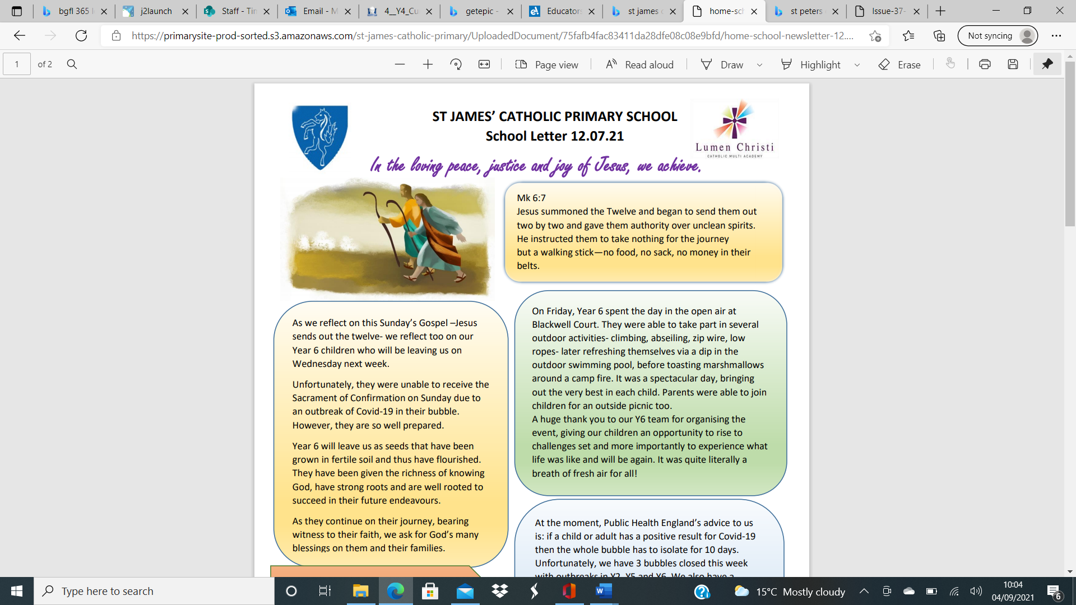
St James’ Curriculum Overview Spring Term
This Term, Year 4 are learning about:


