English  In English this term we will begin by preparing to write a formal persuasive letter based on a previous unit of work completed on London. The children will be taught to use the correct language and presentation features to help persuade someone to visit the city of London.  They will also study ’Lob’ by Linda Newbury, learning about the story of the mysterious Green Man and the changing seasons of the year. They will write in role as key characters and make use of figurative language in their own narrative texts based on the book. | Maths  The children will further develop their understanding and application of formal written methods for multiplication and division.  They will learn about decimal notation and link this to what they know about fractions. They will be taught about tenths and hundredths, equivalent fractions and how to simplify them.  They will revisit how to add and subtract fractions as well as how to find a fraction of a quantity.  The children will also carry out a short block of work on finding the area of a shape. | Science  During the first half term the children will complete a unit of work on Classification. They will learn about classification keys and use them to identify different species of plants and animals. The children will become familiar with the terms vertebrates and invertebrates. They will also be able to identify the key features of reptiles, amphibians, mammals, fish and birds as well as insects, arachnids and molluscs.  In the second half term we will be learning about states of matter and the water cycle. The children will develop their understanding of evaporation and condensation and precipitation.
History  This term, we will be learning about ‘Life in Ancient Rome’. This unit builds on what they learnt about in Year 2. We will learn about the changing political context of Rome-from being governed by a monarchy, to the Republic and the Empire. They will also look at similarities and differences between democracy in Rome and democracy in Britain today. In addition, we will also begin to learn about Rome’s social classes and compare the lives of Patricians, Plebeians and Slaves. During this unit, we will learn about the everyday lives of Roman citizens and the types of leisure activities that they enjoyed. We will also look at artefacts found at Pompeii to find out more about the past and use their knowledge of the Romans to interpret what they teach us about life in Ancient Rome. The children will also look at one important legacy of Ancient Rome-the Latin language. |  | PSHE  This half term in PSHE, Year 4 will be looking at negotiation and compromise and consequences of behaviour. We will be exploring positive and healthy choices and our rights and responsibilities
Geography  In Geography, children will be exploring Mediterranean Europe. We will be focusing on Southern France, Portugal, Spain, Italy, Greece, Malta, and Cyprus. Throughout this half-term, we will explore the warm and dry climates. We will discuss how the effects of the hot, dry summers and cooler wetter winters effect the food and farming. The landscapes and, settlements in Lisbon, Madrid, Rome, Milan, Venice and Athens will also be explored to compare how people live. |  | Computing  Year 4 will create programs by planning, modifying, and testing commands to create shapes and patterns. They will use Logo, a text-based programming language.
Physical Education  The children will complete a unit of work on Dance using the James Bond and Mission Impossible themes as the inspiration for their own routines. They will learn how to perform a ‘slide and roll’ and incorporate movements which reflect a superhero theme in the last few weeks.  After half term, we will move on to Athletics. The children will investigate ways of running, jumping and throwing using different equipment to measure, time and compare different styles. | Music  The children will continue to learn about great composers, this half term focusing on Gustav Holt and his famous work, ‘The Planets.’  They will then begin to learn about how to write music and what different musical notes represent. They will be taught the terms minim, crotchet and semibreve and recognise these on a stave.  The children will continue to develop their skills when playing music, through their weekly trumpet lesson. | Art  In art year 4 will be looking at how the different elements of artwork together and how artists design what they create. We will look at the design of pictures by Matisse in his book Jazz and the effect of the design of The Scream by Munch. We will make our own works of art based on these.
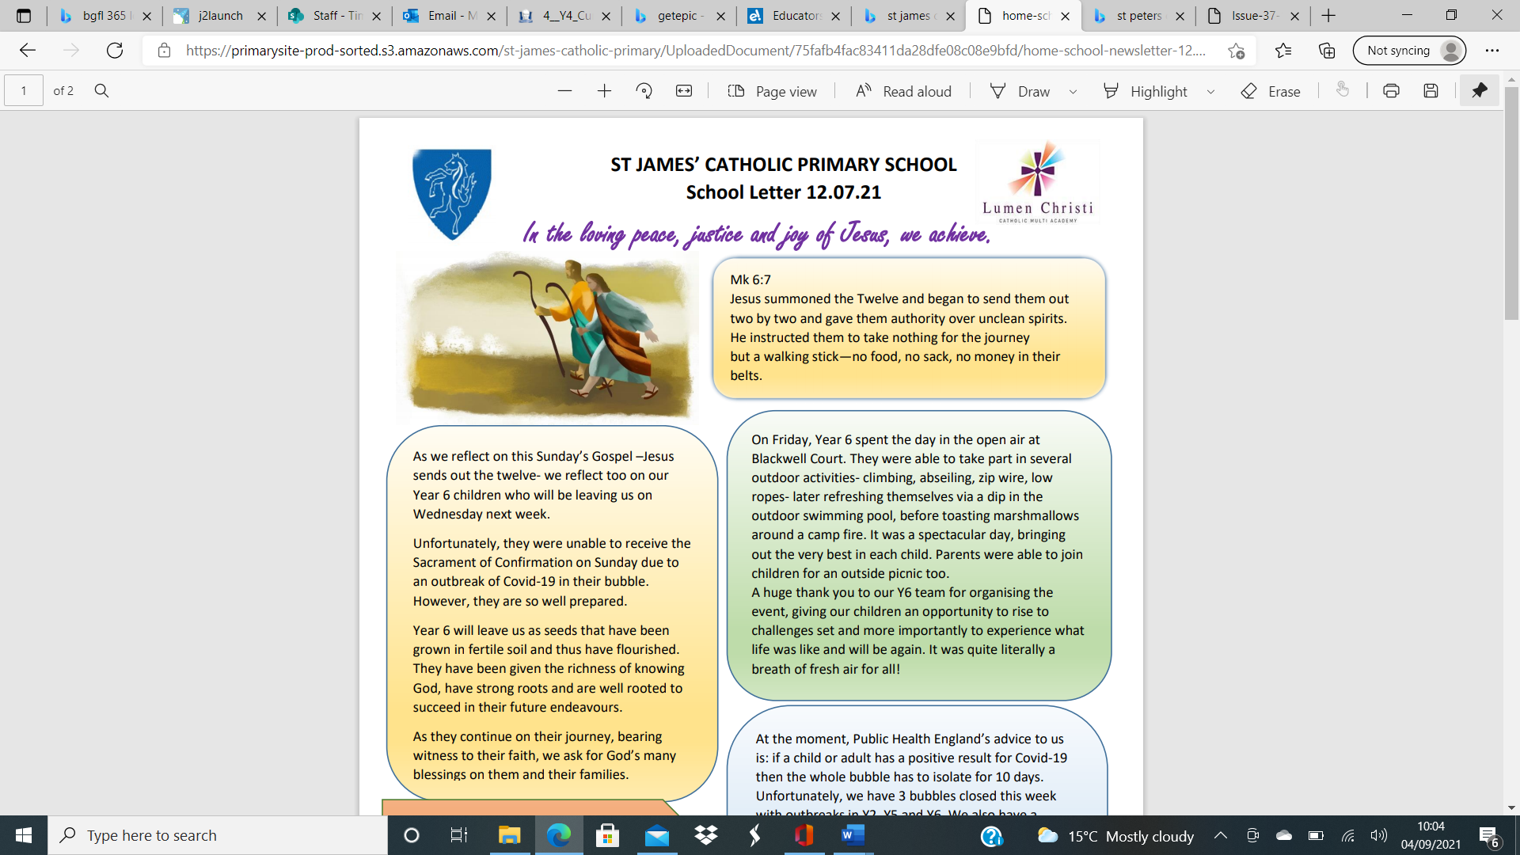
St James’ Curriculum Overview Spring Term
This Term, Year 4 are learning about:


