OUR LADY OF PERPETUAL SUCCOUR AND ST JOHN FISHER R C CHURCHES
Leach Green Lane, B45 9BQ and Cofton Road, B31 3QT – Birmingham
Parish Priest: Fr Srinu Bonthu - fr.srinu.bonthu@rcaob.org.uk , 0121 453 3452
Parish Priest Residence Address: 1 Quarry Walk, Leach Green Lane, Rednal, B45 9BQ, Birmingham, UK
Birmingham Diocesan Trust, Registered Charity No. 234216
Our Lady of Perpetual Succour (OLPS) | St John Fisher (SJF)
Parish Office :ol.rednal.bham@rcaob.org.uk 0121 453 3452 | Parish Office: stjohn.fisher.wheath@rcaob.org.uk 07419581916
Parish Safeguarding : sg.ol.rednal.bham@rcaob.org.uk | Parish Safeguarding : sg.stjohn.fisher.wheath@rcaob.org.uk
Parish Hall: olrhallbookings@outlook.com | Parish Hall: stjohn.fisher.wheath@rcaob.org.uk

SOLEMNITY OF PENTECOST– 8TH JUNE, 2025
Readings: Acts 2:1-1; Psalm 103; 1 Corinthians 12:3-7,12-13; John 20:219-23
Psalm response: Send forth your spirit, O Lord, and renew the face of the earth.
Saturday 7th June 2025 - Baptism  Inter – Cultural Mass  Confessions  FEAST OF PENTECOST  Holy Spirit Retreat  Baptism Preparation Meeting | 10:00 am St John Fisher  12:00 noon St Brigid’s  3:00 pm Our Lady’s  4:00 pm Our Lady’s  10 - 5 pm St. John Fisher  5:30 pm St John Fisher | Hattie Gwendoline Brennan  Intercultural Mass  Confessions  Rita & Phil Jackson – Golden Wedding  Holy Spirit Retreat  Baptism Preparation Session
Sunday 8th June 2025 FEAST OF PENTECOST  Baptism | 9:00 am St. John Fisher  11:00 am Our Lady’s  1:00 pm Our Lady’s | +John Smallwood & +Patrick Divney  +John Woodward & +Reggie Baldwin  Alice Irena Chrobot
Monday 9th June | 12:00 noon Haunton | +Deacon Tony Rigby Funeral Mass
Tuesday, 10th June | 9:00 am – 4:00 pm  6:30 pm St John Fisher | Conference for Priests  Life in the Spirit Meeting
Wednesday 11th June- Funeral service | 10:00 am Yardley Crem | +Francis Patrick Nock
Thursday 12th June | 10:00 am Our Lady’s  1:00 pm – 4pm St Paul’s | +Kathleen McNamee and +Steve McNamee  Confessions
Friday13th June Mass and Confessions | 12 Noon St John Fisher | +Leo & Nellie McConvery & +Rodney Bowater
Saturday 14th June 2025  Confessions  Solemnity of the Most Holy trinity | 11:00 am Our Lady’s  3:00pm Our Lady’s  4:00pm Our Lady’s | First Holy Communion for St Columba’s School  Confessions  O. C. Mathew - Thanksgiving
Sunday 15th June 2025 - Father’s Day  Solemnity of the Most Holy Trinity | 9:00 am St. John Fisher  11:00 am Our Lady’s | + Deborah Edward  M. Mathew - Thanksgiving
Please pray for those whose Anniversaries occur around this time: June 1 Bridget McGrath, Katie Galligan, Bridget Harbridge, 2 Ellen O’Donovan, Philip Carn, Incoronato DelVecchio, 3 Francis Lyons, Paul Cox, Richard Hardy, 4 Ernest Keys, Denis Slattery, Thomas Brown, 5 Thomas Kelly, Lilian Molloy, Teresa Shiels, Michael McCabe, Eileen Kavanagh, 6 Emily Hooton, Cecily Marchant, 7 James Conroy, Christopher Mountford, Sheila McGrath, Anthony Miele, William Young, 8 Kathleen McEwan9 Mgr Bernard Robinson, Fr John P Lane, Maurice O’Connor, Harold Ellerker, Philip Hughes, Julia Keily, 10 Brigid Mahony, Edna Gibbs, Eva Salmon, 11 Eva Connor, Patrick Lehane, Nathaniel |Lawani, 12 Kathleen Fitzpatrick, Edward Reilly, Kathleen McNamee, Jack Nicholls, 13 Rebecca Bech, George Taylor, Doris Harrison, 14 Danny Brown,15 Bridget McIntyre and Brian Stark.
Please Pray for the following who are Sick: Margaret Owen, Carol Spooner, Dave McGrath, Margaret Cooper, Fr Tony Rohan, Ann Docherty, Nancy Witcomb, Maz Boyce, Lily McKenna, Victor, Margaret Izon, Carl Brookes, Peter Flanaghan, Pat Farrell, Mark Hurley, Peter Rafferty, Mary Molloy, Andrea Byrne, Rita Fitzpatrick, Fr Gerry Lennon, Ann Glenn, Pat Curly, Linda Bennett, Jo MacAleenan, Margaret Smythe, Jackie Whitehead, Philip Coleman, Michelle Wright, Margaret Dowling, Marion Sturdy, Brendan Lawless, Eileen Brown, Joe Moss, Audrey Jones, Kevin Nolan, John Donnelly, Steve Moore, Margaret Duggan, Chris Kennedy, Christine Morrison and Peter Vince.
Our Lady of Perpetual Succour (OLPS) |  | St John Fisher (SJF)
Gift Aid: £174.90 | Total £571.81  Church Mass Attendance:203 | Gift Aid £220.50 | Total: £ 494.18  Church Mass  Attendance:178
Lose Money: £364.41  Contactless: £32.50  Catholic Communications: £51.45 | Total £571.81  Church Mass Attendance:203 | Loose Money: £80  Card Machine: £193.68  Catholic Communications: £118.28 | Total: £ 494.18  Church Mass  Attendance:178
Second Collection – Church/hall renovations |  | Second Collection – Church building fund
A gentle reminder to all parishioners from Fr. Srinu. As we gather each week to celebrate Holy Mass, let us remember that our Churches are sacred spaces, places of prayer, reflection and reverence. For this reason, please keep all conversations to a minimum inside Church, especially before Mass begins. This time is precious for many who come early to pray, prepare their hearts and join in the Holy Rosary. Out of respect for one another and for the presence of the Blessed Sacrament, please maintain a spirit of sacred silence within the Churches. Fellowship and conversation are a joyful part of our parish life, and we warmly encourage these to continue in the Parish Centre or Hall or outside after Mass. Thank you for helping to preserve the peace and reverence of our shared worship spaces. God bless.
Holy Rosary: Pease try and come to Mass a little early on Sundays so that you can join in praying the Rosary. The Rosary begins at 8:30 am at SJF and 10:30 am at Our Lady’s. Please join us to pray for peace. Thank you.
Baptism Preparation Sessions: Saturday June 7th, 2025, at 5:30 pm in St John Fisher Church, Cofton Road, B31 3QT and Saturday July 5th, 2025, at 5:30 pm in Our Lady’s Church on Leach Green Lane, Rednal – B45 9BQ and Saturday,30th August 2025 at 5:30 pm in St John Fisher Church, West Heath. It is compulsory for those parents who wish to have their children baptised in our parish Churches to attend one of these meetings.
Deaths: Please pray for Mr Giovanni Antonio Esposito (Age 96) of St Chad’s Road, Marianne Rosser and Trevour O’Brien, John Patrick Logan, who died recently. Please pray too for Francis Patrick Nock whose funeral service will be held at Yardley Crematorium at 10:00 on Wednesday 11th June and Mr John Desmond Woodward who will be received into Our Lady’s Church, Rednal on Monday 23rd June 2025 at 5:00 pm, followed by Funeral Requiem Mass on Tuesday 24th June 2025 at 11:00 am and cremation at Redditch Crematorium.
Life in the Spirit Seminars - One of POPE FRANCIS’ enduring wishes was for the whole Church to live IN THE POWER OF HOLY SPIRIT. He personally endorsed a course called Life In the Spirit Seminars. So, we are going to hold the course in the Parish, and you are invited. There are 7 seminars in St John Fisher’s Hall on Tuesday evenings 6.45pm-8.00pm, starting 6 May and ending 17 June; and an important Holy Spirit Retreat on Saturday 7 June from 1.00pm to 5.00pm. It is designed for those new to the faith, as well as those who have been Catholics for much longer. Everyone who wants to experience the refreshment of the Holy Spirit in their faith lives is welcome.
SVP: Dear Friends, our next Food Parcels are on THURSDAY, 19th JUNE. We are truly grateful to all parishioners who regularly donate non-perishable food to our food bank. AT PRESENT OUR FOOD STOCKS ARE LOW; we rely totally on your generous food donations to keep this much needed service active, so we ask ALL parishioners to consider helping us. We always need: BAKED BEANS, TINNED TOMATOES, TINNED/DRIED SOUPS, LONG LIFE MILK, COOKING SAUCES, TINNED VEG, TINNED FRUIT, TINNED RICE PUDDING, BISCUITS, CEREALS, TEA/COFFEE/HOT CHOCOLATE, PASTA, RICE, TOILETRIES, TOILET ROLLS, TINNED TUNA AND ANY OTHER SUITABLE ITEMS. Please consider donating A COUPLE OF ITEMS EACH WEEK to help keep the food bank well stocked. Please take your donations to your usual drop off point or bring them to Our Lady’s Parish Hall from 10:30am to 11:30am on THURSDAY 19th June. The remaining food parcels for this term are 3rd July and 17th July. If you have any queries, please contact Pauline on 07810 557197.
Our Lady’s Parish Events dates for your diary: Family BBQ- 19th July; Multicultural Night- 27th September; Christmas fayre – 29th November and Rob & Kath’s Christmas Party- 6th December.
Family Resources: A free and growing number of children's liturgy and family resources can be found at Annunciation Catechesis. Please visit their website to see what is available and how they can support your parish ministries! The Annunciation

The ‘We Believe’ Festival takes place from 25th to 28th July at Oscott College. It is the first such gathering of Catholic life, involving a variety of ministries and speakers. Tickets can be accessed via www.webelievefestival.com/tickets. The early bird discount offer for tickets ends on 31st May next.
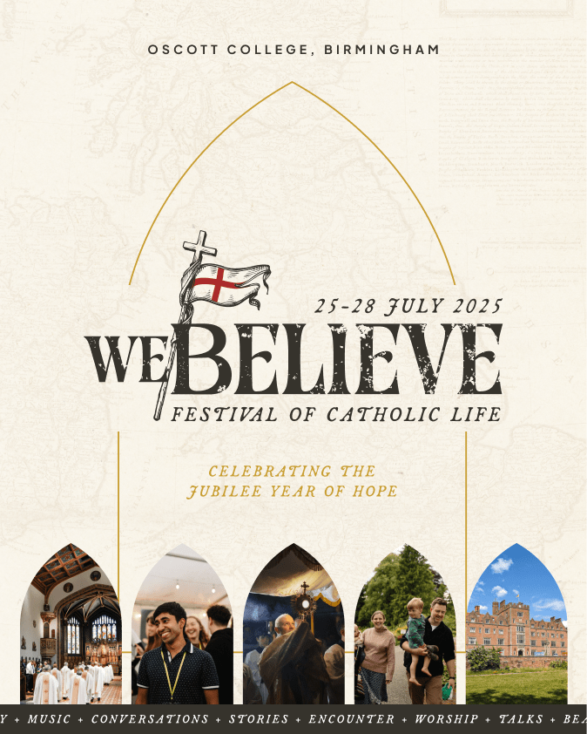
The Catholic Union extend an invitation to their Annual Summer Gathering which will be held at Worth Abbey on 12th July. The day coincides with the 50th anniversary of the Consecration of Worth Abbey Church. In this Jubilee Year, the Arundel and Brighton Diocese has designated the Church as one of its three special places pilgrimage, where Holy Year indulgences may be gained. For those interested, please see ... info@catholicunion.org.uk

Holy Mass: Asking for a Mass to be offered for a special intention is a significant act of love and faith. It strengthens intercessory prayer, connects individuals with Christ’s sacrifice and provides spiritual benefits for the living and the deceased. It is also a way of asking for God’s grace and intercession for the needs of others. If you would like Fr. Srinu to offer Holy Mass for a special intention, please write the intention on an envelope, include an offering and also a preferred date for the Mass to be offered.
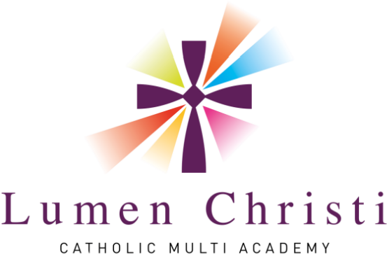
TASTER EVENING: St. Thomas Aquinas Catholic School - Mon 30th June 2025, 5–7_{pm -} Brief information, talks, Fun activities, Refreshments, Tours. PLUS, opportunities to meet academy board members, headteachers, staff and many children from STACS

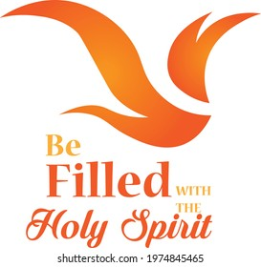
When we speak about the Holy Spirit, we speak about the Breath of God, breathing in us. The Spirit of God is like our breath. God’s Spirit is more intimate to us, than we are to ourselves. The Holy Spirit of God prays in us, offers us the gifts of love, forgiveness, kindness, goodness, gentleness, peace and joy. It is the Holy Spirit who offers us the life that death cannot destroy. Let us always pray:
‘Come, Holy Spirit, Come’.

Wishing you all happy Pentecost Sunday – birthday of the holy catholic church
Thank you all for your kind help and generous support. God Bless you. Please join our Parish Family after Sunday Mass in the Parish Hall to build new friendships.

