OUR LADY OF PERPETUAL SUCCOUR AND ST JOHN FISHER R C CHURCHES
Leach Green Lane, B45 9BQ and Cofton Road, B31 3QT – Birmingham
Parish Priest: Fr Srinu Bonthu - fr.srinu.bonthu@rcaob.org.uk , 0121 453 3452
Parish Priest Residence Address: 1 Quarry Walk, Leach Green Lane, Rednal, B45 9BQ, Birmingham, UK
Birmingham Diocesan Trust, Registered Charity No. 234216
Our Lady of Perpetual Succour (OLPS) | St John Fisher (SJF)
Parish Office :ol.rednal.bham@rcaob.org.uk 0121 453 3452 | Parish Office: stjohn.fisher.wheath@rcaob.org.uk 07419581916
Parish Safeguarding : sg.ol.rednal.bham@rcaob.org.uk | Parish Safeguarding : sg.stjohn.fisher.wheath@rcaob.org.uk
Parish Hall Booking: pkenn1958@gmail.com | Parish Hall: stjohn.fisher.wheath@rcaob.org.uk

TWENTIETH SUNDAY IN ORDINARY TIME– 17th August, 2025
Readings: Jeremiah 38:4-6, 8-10; Psalm 39 Hebrews 12:1-4; Luke 12:49-53
Psalm response: Lord come to my aid.
Saturday 16th August 2025 - Confessions  Celebrate Weekend till Wednesday | 3:00 pm Our Lady’s  4:00 pm Our Lady’s | Confessions  For young people receiving A Level results
Sunday 17th August 2025  20th SUNDAY IN ORDINARY TIME | 9:00 am St. John Fisher  11:00 am Our Lady’s | Thanksgiving – Anthony and Claire McHugh  +Ramola Monacha
Monday 18th Reception into Church | 6:00 pm – Mount Carmel | +Fr Tony Rohan
Tuesday, 19th -Funeral Requiem Mass | 12:00 pm – Mount Carmel | +Rev Fr. Tony Rohan
Thursday 21st August  Reception into church | 10:00 am Our Lady’s  6:00 pm St John Fisher | Jenny Gibb Intentions  +Teresa Mary Shaw
Friday 22nd August - Requiem | 11:00 am St John Fisher | +Teresa Mary Shaw
Saturday 23rd August 2025 - Confessions  21st Sunday in Ordinary Time | 3:00 pm Our Lady’s  4:00 pm Our Lady’s | Confessions  For young people receiving GCSE results
Sunday 24th August 2025  21st SUNDAY IN ORDINARY TIME | 9:00 am St. John Fisher  11:00 am Our Lady’s | Donna Waldron for recovery  +Eugee O’Reilly
Please pray for those whose Anniversaries occur around this time: 16 Chloe McNaught, Ann Maye, Brenda Lee, 17 Nora Higgins, Ann Cronin, Michael Smith, 18 Andrew McGrath, 19 Mary Skelly, Marie Rogers, Mary Johnston, 20 Ethel Parsons, Henry Hooton, Alfred Lane, Francis O’Loughlin, 21 Mary McGuinness, Wanda Warrilow, David Westwood, 22 Bernard Stonier and Stephen Smith.
Please Pray for the following who are Sick: Margaret Owen, Carol Spooner, Dave McGrath, Margaret Cooper, Nancy Witcomb, Maz Boyce, Lily McKenna, Victor, Margaret Izon, Carl Brookes, Peter Flanaghan, Pat Farrell, Mark Hurley, Peter Rafferty, Mary Molloy, Andrea Byrne, Rita Fitzpatrick, Fr Gerry Lennon, Ann Glenn, Pat Curly, Linda Bennett, Jo MacAleenan, Margaret Smythe, Jackie Whitehead, Philip Coleman, Michelle Wright, Margaret Dowling, Marion Sturdy, Brendan Lawless, Eileen Brown, Audrey Jones, Kevin Nolan, Margaret Duggan, Chris Kennedy, Christine Morrison, Peter Vince, Donna Waldron and baby Sebastian James, Jim and Ruth.
Our Lady of Perpetual Succour (OLPS) |  | St John Fisher (SJF)
Gift Aid: £142.00 | Total £568.67  Church Mass Attendance: 212 | Gift Aid £92.10 | Total: £342.33  Church Mass  Attendance: 156
Lose Money: £266.67  Contactless: £160.00  Garden Maintenance: £68.81 | Total £568.67  Church Mass Attendance: 212 | Loose Money: £102.75  Card Machine: £147.48  Church Roofs £95.62 | Total: £342.33  Church Mass  Attendance: 156
Second Collection – Gardens Maintenance |  | Second Collection – Church Roofs
Deaths: Please keep Baby Evelyn Louise Suffolk McKenna in your prayers, who sadly passed away recently and kindly remember her parents Conor McKenna and Karl Suffolk as well during this deeply difficult and heartbreaking time. Pray for Teresa Mary Shaw who will be received into St John Fisher church at 6.00pm on Thursday 21st August, followed by Funeral Requiem Mass on Friday 22nd August at 11:00 am and burial at Waseley Hills Cemetery. The reception of the late Fr. Tony Rohan’s remains will be brought into the Church of Our Lady of Mount Carmel, Redditch at 6 pm on Monday, 18th August, followed by his Funeral Mass on Tuesday, 19th August at 12 pm. Fr. Tony will be buried at the Abbey Cemetery, Redditch. Please pray for the repose of the soul of Fr. Paul Johnson, Parish Priest of St. Ambrose Barlow, Hall Green, Birmingham who died on Thursday 7th August. Fr. Paul was ordained in 2009 and served as assistant priest in the parish of Christ the King, Coventry. He became parish priest of St. Joseph’s, Warndon and then moved to become parish priest at St. Ambrose Barlow. We pray for his mother, Margaret, his sister Karen and his niece Georgia and the members of his parish community who now mourn him.

Men’s Emmaus Retreat - Bookings are now being taken for this retreat from 7th to 9th November 2025 at The Hayes Conference Centre, Derbyshire. The cost for the weekend is £200 which includes all food and accommodation. The Keynote Speaker throughout the weekend will be David Wells and Mass will be celebrated by Bishop Timothy Menezes on Saturday, 8th November: Select tickets – Emmaus Men's Retreat – The Hayes Conference Centre
ALPHA: If you are interested in finding out about the Catholic Faith, please contact Fr Srinu or Annie Gannon. We are planning to start an Alpha course from September. Please register and send an email to the office at: ol.rednal.bham@rcaob.org.uk. If you are new to the parish, you are very welcome. Do please introduce yourself to us and if we can be of any help to you then please let us know. We also warmly welcome any visitors on holiday in the area.
Baptism Preparation Sessions: Next meeting 30th August 2025 at 5:30 pm in St John Fisher Church, West Heath. It is compulsory for those parents who wish to have their children baptised in our parish Churches to attend one of these meetings.
Sacrament of Confirmation: Preparation for the Sacrament of Confirmation for children in Year 6 and older who are not in Catholic Schools. Please contact the Parish Office (details at the top of the newsletter) or Julia McHugh 07830109047 for more information.
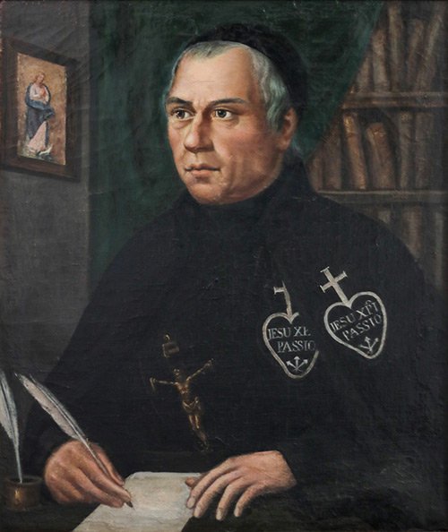
Summer Club at Our Lady’s begins this week: 10:00am -3:00pm in Our Lady’s Hall 20th-22nd August and 26th–28th August. To register please contact Sarah on her mobile: 07876543769
Blessed Dominic Barberi: Monday marks the beginning of the Diocesan Novena to pray for the Canonisation of Blessed Dominic Barberi. The Novena of Prayer lasts for nine days and concludes on his feast day on Tuesday 26 August. The annual Novena of Prayer for Blessed Dominic Barberi is a moment to pause and to appreciate the work of this holy Passionist in our Archdiocese and to pray for his Canonisation. Blessed Dominic arrived in the Archdiocese in February 1842. He spent the next seven years based at Aston Hall in Staffordshire, from where he celebrated Mass, preached Missions, heard confessions, and received many people into the Catholic Church, the most famous being St John Henry Newman in October 1845. Blessed Dominic had a reputation for sanctity and holiness of life. He is also remembered for his love for the poor and those in need of prayer and help. In our Archdiocese his memory is held in special regard and each year we pray a Novena asking God to grant a miracle of healing through his intercession, which could further his cause for Canonisation. Please pray the Novena during the nine days from August 18 until August 26. It can be prayed in the parish or at home.
Novena Prayer for the Canonisation of Blessed Dominic Barberi
O God, who so lovingly raised Blessed Dominic to the heights of holiness, learning and apostolic zeal
and made him a powerful minister of your mercy, listen to our humble request.
We pray that you will in your goodness, grant a miracle through the intercession of Blessed Dominic,
so that the Church may further honour him on earth and that many more people will come to know
and invoke the help of this faithful servant of the Church. We ask this through Christ Our Lord. Amen.
Mary, Mother of Holy Hope, Pray for Us.
Saint John Henry Newman, Pray for Us.
Blessed Dominic Barberi, Pray for Us.

SVP: Dear Friends, we thank you all most sincerely for all your generous support throughout this academic year. We ask you to continue collecting nonperishable food items for us throughout the summer and donate them to us in September. We wish you all a relaxing, enjoyable and safe summer break and look forward to your continued support next academic year.
The monthly Mass for those with (SEN) (Special Educational Needs) will be celebrated next Sunday 24th August at St. Brigid’s Church, Northfield at 4.00 pm. All welcome.
Holy Rosary: Pease try and come to Mass a little early on Sundays so that you can join in praying the Rosary. The Rosary begins at 8:30 am at SJF and 10:30 am at Our Lady’s. Please join us to pray for peace in the world. Thank you.
St. Chad’s Cathedral - For those interested, a tour of the Cathedral will take place next Friday, 22nd August. The tour begins at 10.30 am and lasts for one hour. Those attending should meet at the entrance to the Cathedral.
Harvington Hall: This year’s pilgrimage to Harvington Hall, the Shrine of the English Martyrs, takes place on Sunday, 7th September. Confessions take place from 1.45 to 2.30 pm and Mass will be celebrated at 3 pm. For those hoping to go, please bring your own chairs and a packed lunch.
The Kenelm Youth Trust invites young adults across the Archdiocese to join in Adorare – a night of Encounter, Praise and Worship on Friday, 29th August at the Friary, St Bernard’s Road, Olton. For more information, see the Diocese website.
The 2025 National Jubilee Walking Pilgrimage of Hope is now open for day pilgrim registration. The route of the Pilgrimage will include some local Churches, namely St. George’s, Worcester, St. Peter’s, Bromsgrove and St. Mary’s, Harborne. Pilgrims walking the St. Matthew’s Way from Cardiff will arrive at St. Mary’s on Sunday, 7th September at 4 pm.
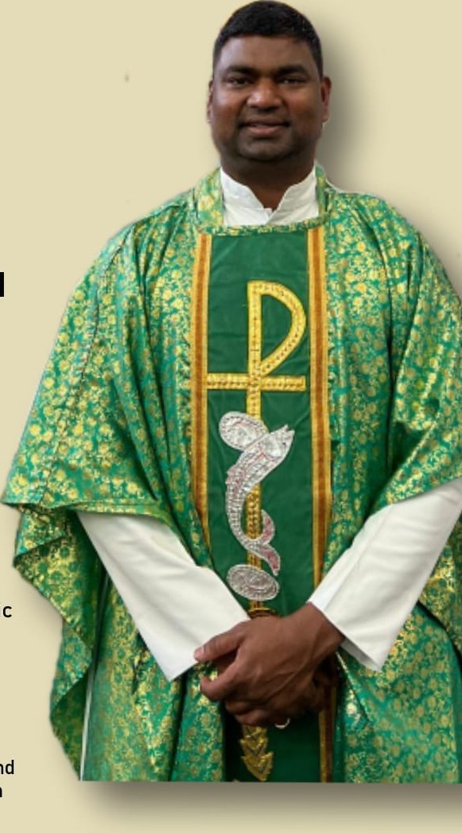
Father Hudson’s Caritas (FHC), the social care agency of the Archdiocese, are appealing for individuals to step forward to act as Parish Ambassadors. The role is to act as a link between the charity and the local parish. For more information, please see the Diocesan website.

Farewell Celebration for Rev Fr Subba, hosted by St Augustine’s Parish, Handsworth wood: We warmly welcome the Parishioners from Our Lady’s and St John Fisher to join together to bid a fond farewell to Fr Subba before his return to India. This will be a time of fellowship, gratitude, a touch of sadness and community celebration. Date: Saturday, 30th August 2025. Time: 6:00 pm, Venue: St Augustine Catholic Primary School Hall on Avenue Road, Hansdsworth, Birmingham, B21 8ED. All are welcome.
Thank you all for your kind help and generous support. God Bless you. Please join our Parish Families after both Sunday Masses in their respective Parish Halls to build new friendships.

