OUR LADY OF PERPETUAL SUCCOUR AND ST JOHN FISHER R C CHURCHES
Leach Green Lane, B45 9BQ and Cofton Road, B31 3QT – Birmingham
Parish Priest: Fr Srinu Bonthu - fr.srinu.bonthu@rcaob.org.uk , 0121 453 3452
Parish Priest Residence Address: 1 Quarry Walk, Leach Green Lane, Rednal, B45 9BQ, Birmingham, UK
Birmingham Diocesan Trust, Registered Charity No. 234216
Our Lady of Perpetual Succour (OLPS) | St John Fisher (SJF)
Parish Office :ol.rednal.bham@rcaob.org.uk 0121 453 3452 | Parish Office: stjohn.fisher.wheath@rcaob.org.uk 07419581916
Parish Safeguarding : sg.ol.rednal.bham@rcaob.org.uk | Parish Safeguarding : sg.stjohn.fisher.wheath@rcaob.org.uk
Parish Hall Booking: pkenn1958@gmail.com | Parish Hall Booking: Obinna.iloka@outlok.com, 07424209628.

TWENTY-FIRST SUNDAY IN ORDINARY TIME– 24th August, 2025
Readings: Isaiah 66:18-21; Psalm 116 Hebrews 12:5-7,11-13 Luke 13:22-30
Psalm response: Go into all the world and proclaim the Good News.
Saturday 23rd August 2025 - Confessions  21st Sunday in Ordinary Time | 3:00 pm Our Lady’s  4:00 pm Our Lady’s | Confessions  For young people receiving GCSE results
Sunday 24th August 2025  21st SUNDAY IN ORDINARY TIME | 9:00 am St. John Fisher  11:00 am Our Lady’s | John O’Keeffe – 87th B’day &  Christina and Mark Duce – 40th Wedding  +Eugene O’Reilly
Saturday 30th August 2025 Baptism  Confessions  22nd Sunday in Ordinary Time  Baptism Preparation Meeting | 11:00 am St John Fisher  3:00 pm Our Lady’s  4:00 pm Our Lady’s  5:30 pm St John Fisher | Frank Paul and Nancy Hickling  Confessions  +Florentina Vlad, Edgar Hernandez, Ricardo Hermandez  Baptism Preparation Session Meeting
Sunday 31st August 2025  22nd SUNDAY IN ORDINARY TIME  Baptism | 9:00 am St. John Fisher  11:00 am Our Lady’s  1:30 pm St John Fisher | Sean and Sheila McConvery – 40th Wedding  & +Maureen Duce - Anniversary  +Peter Blakehurst– 1st Anniversary  Janelle Elizabeth Cofie
Please pray for those whose Anniversaries occur around this time: 23 Mary Brown, Madeleine McGinley, J. Orzechowska, B. Bone, John McNichol, 24 Mary Daly, Anne McDaid, 25 Olive Hadley, George Desmedt, Susan Bonner, 26 Tony O’Brien, Margaret Doherty, Margaret Georgiou, Dora Burr, 27 Mary Dawson, 28 Bernard Duffy, Lillian Coppejans, William Fitzgerald, Harry Byrne, 29 Gerard Troy, William Nickless, Bobby Betham, Nancy Coulson.
Please Pray for the following who are Sick: Margaret Owen, Carol Spooner, Dave McGrath, Margaret Cooper, Nancy Witcomb, Maz Boyce, Lily McKenna, Victor, Margaret Izon, Carl Brookes, Peter Flanaghan, Pat Farrell, Mark Hurley, Peter Rafferty, Mary Molloy, Andrea Byrne, Rita Fitzpatrick, Fr Gerry Lennon, Ann Glenn, Pat Curly, Linda Bennett, Jo MacAleenan, Margaret Smythe, Jackie Whitehead, Philip Coleman, Michelle Wright, Margaret Dowling, Marion Sturdy, Brendan Lawless, Eileen Brown, Audrey Jones, Kevin Nolan, Margaret Duggan, Chris Kennedy, Christine Morrison, Peter Vince, Donna Waldron and baby Sebastian James, Jim and Ruth.
Our Lady of Perpetual Succour (OLPS) |  | St John Fisher (SJF)
Gift Aid: £ 112.00 | Total £ 529.38  Church Mass Attendance: 178 | Gift Aid £180.00 | Total: £936.73  Church Mass  Attendance: 218
Lose Money: £254.00  Contactless: £105.00  Maintenance: £58.38 | Total £ 529.38  Church Mass Attendance: 178 | Loose Money: £194.15  Card Machine: £132.73  Church Roofs £230.00  Piety Stall: £200.00 | Total: £936.73  Church Mass  Attendance: 218
Second Collection – |  | Second Collection
Deaths: Please keep Evelyn Louise Suffolk McKenna will be received into Our Lady’s Church – Rednal on Thursday 04th September 2025 at 4:30 pm and followed by Funeral Service on Friday 05th September 2025 at 12:00 noon and followed by Cremation at Waseley Hills Crematorium. May she rest in peace. Amen.

Men’s Emmaus Retreat - Bookings are now being taken for this retreat from 7th to 9th November 2025 at The Hayes Conference Centre, Derbyshire. The cost for the weekend is £200 which includes all food and accommodation. The Keynote Speaker throughout the weekend will be David Wells and Mass will be celebrated by Bishop Timothy Menezes on Saturday, 8th November: Select tickets – Emmaus Men's Retreat – The Hayes Conference Centre
ALPHA: If you are interested in finding out about the Catholic Faith, please contact Fr Srinu
or Annie Gannon. We are planning to start an Alpha course from September. Please register and
send an email to the office at: ol.rednal.bham@rcaob.org.uk. If you are new to the parish, you
are very welcome. Do please introduce yourself to us and if we can be of any help to you
then please let us know. We also warmly welcome any visitors on holiday in the area.

Baptism Preparation Sessions: Next meeting is next Saturday, 30th August 2025 at 5:30 pm in St John Fisher Church, West Heath. It is compulsory for those parents who wish to have their children baptised in our parish Churches to attend one of these meetings.

Sacrament of Confirmation: Preparation for the Sacrament of Confirmation for children in Year 6 and older who are not in Catholic Schools. Please contact the Parish Office (details at the top of the newsletter) or Julia McHugh 07830109047 for more information.

Summer Club at Our Lady’s continues this week: 10:00am -3:00pm in Our Lady’s Hall, 26th–28th August. To register please contact Sarah on her mobile: 07876543769.
Date for your diary: Our next Parish event will be a quiz on Saturday 30th September. Further details to follow.
Novena Prayer for the Canonisation of Blessed Dominic Barberi
O God, who so lovingly raised Blessed Dominic to the heights of holiness, learning and apostolic zeal and made him a powerful minister of your mercy, listen to our humble request. We, pray that you will in your goodness, grant a miracle through the intercession of Blessed Dominic,
so that the Church may further honour him on earth and that many more people will come to know and invoke the help of this faithful servant of the Church. We ask this through Christ Our Lord. Amen.
Mary, Mother of Holy Hope, Pray for Us.
Saint John Henry Newman, Pray for Us.
Blessed Dominic Barberi, Pray for Us.
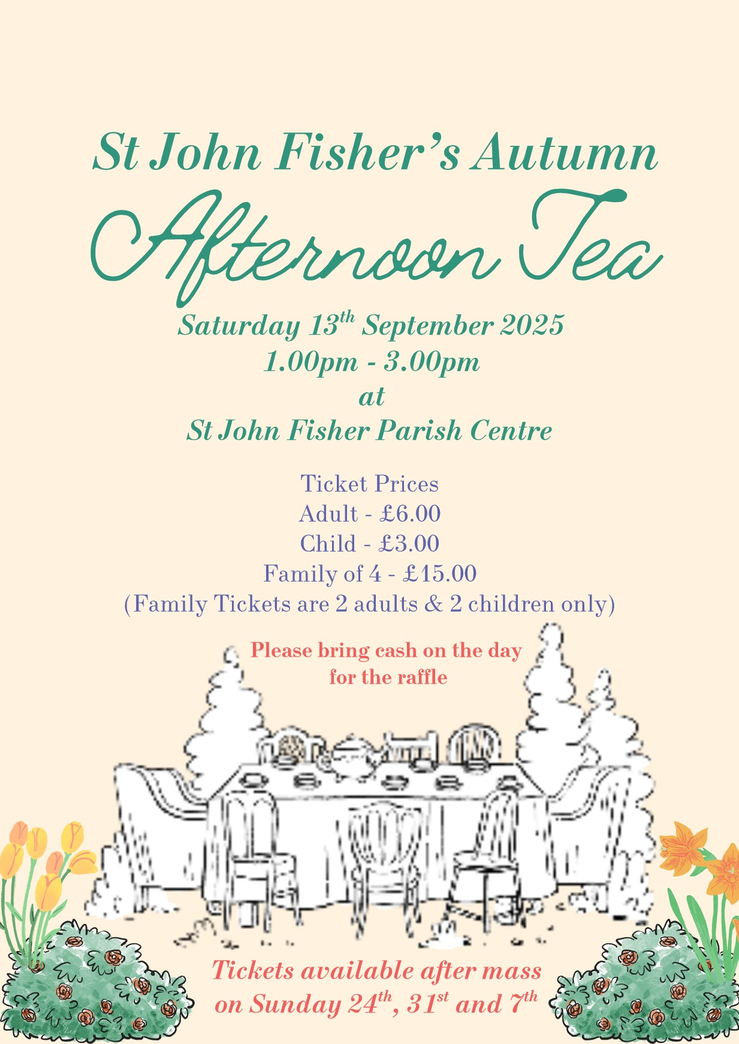
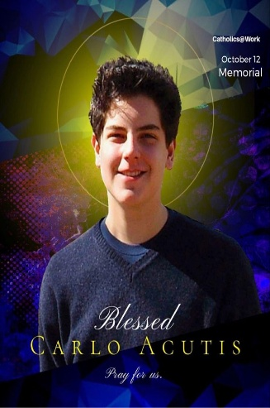
Blessed Carlo Acutis will be canonised on 7th September 2025, making him the first millennial saint recognised by the Catholic Church. Blessed Carlo was only 15 when he died from leukemia. His short life shows us that we don’t need an extended life to become holy. For Blessed Carlo the Eucharist was his ‘highway to heaven’. He wrote: ‘Try to go every day to Mass and receive Holy Communion ... if you can, stay a few minutes every day in Eucharistic adoration in front of the Tabernacle where Jesus is really present’. To mark the canonisation of Blessed Carlo with the whole Catholic community, we’re going to have a shared table celebration after Mass on Sunday, 7th September. Please bring some food on that day and let’s celebrate the recognition of this young person as a saint in heaven. Volunteers will be needed to set out the food in the Parish Centre and to tidy up afterwards. Please see Carmel Bates for more information.
SJF Parish Centre We are very grateful to Obinna Iloka for taking on the management of bookings for the SJF Parish Centre. If anyone is interested in booking the Centre for a function, please contact Obinna at: obinna.iloka@outlok.com or phone mobile number: 07424209628.
SVP: Dear Friends, we thank you all most sincerely for all your generous support throughout this academic year. We ask you to continue collecting nonperishable food items for us throughout the summer and donate them to us in September. We wish you all a relaxing, enjoyable and safe summer break and look forward to your continued support next academic year.
The monthly Mass for those with (SEN) (Special Educational Needs) will be celebrated today, Sunday 24th August at St. Brigid’s Church, Northfield at 4.00 pm. All welcome.
Holy Rosary: Pease try and come to Mass a little early on Sundays so that you can join in praying the Rosary. The Rosary begins at 8:30 am at SJF and 10:30 am at Our Lady’s. Please join us to pray for peace in the world. Thank you.
Harvington Hall: This year’s pilgrimage to Harvington Hall, the Shrine of the English Martyrs, takes place on Sunday, 7th September. Confessions take place from 1.45 to 2.30 pm and Mass will be celebrated at 3 pm. For those hoping to go, please bring your own chairs and a packed lunch.
New season of tours at St. Mary’s College, Oscott There are a range of dates available during the months of September, October and November. Details and times are available on the Diocesan website for those interested.
The Kenelm Youth Trust invites young adults across the Archdiocese to join in Adorare – a night of Encounter, Praise and Worship next Friday, 29th August at the Friary, St Bernard’s Road, Olton. For more information, see the Diocese website.
The 2025 National Jubilee Walking Pilgrimage of Hope is now open for day pilgrim registration. The route of the Pilgrimage will include some local Churches, namely St. George’s, Worcester, St. Peter’s, Bromsgrove and St. Mary’s, Harborne. Pilgrims walking the St. Matthew’s Way from Cardiff will arrive at St. Mary’s on Sunday, 7th September at 4 pm.

Father Hudson’s Caritas (FHC), the social care agency of the Archdiocese, are appealing for individuals to step forward to act as Parish Ambassadors. The role is to act as a link between the charity and the local parish. For more information, please see the Diocesan website.
My Funeral Mass an online version document here: My Funeral Mass | Birmingham Diocesan Trust. This can be filled in on the PDF or downloaded and filled in by hand. I can also check to see if we have any existing hard copies in the office next week- do you know how many you would need?


Thank you all for your kind help and generous support. God Bless you. Please join our Parish Families after both Sunday Masses in their respective Parish Halls to build new friendships.

